Downtown Providence
32 Exchange Terrace, Providence RI

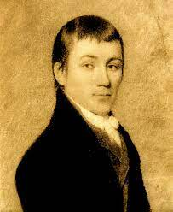
Reservations for Charles Brockden Brown Society

Last Name _____________________________________
First Name _____________________________________

Check in date ____________________________
Check out date __________________________
Number of days_______

Email address _______________________________________________ (needed for hotel confirmation)
Phone Number __________________________
Requests/Notes
_______________________________________________________________________________________________________________________________________________________________________________________________________________________________________________________________

Please email to Helaine.gallagher@crestlinehotels.com or fax to 401-272-1416 Attn: Helaine

